1) Incident trigger

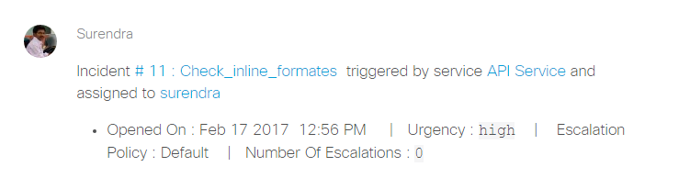

2) Incident assign

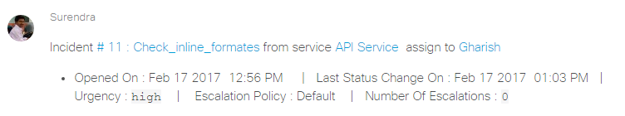

3) Incident delegate

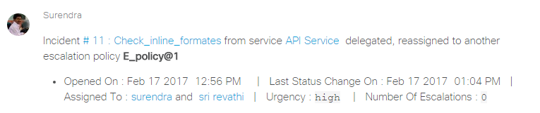

4) Incident escalate

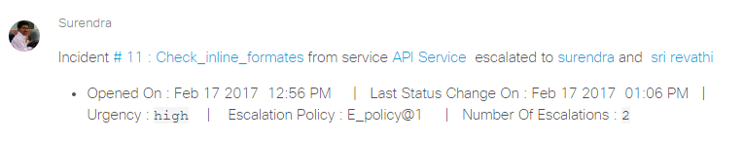

5) Incident acknowledge

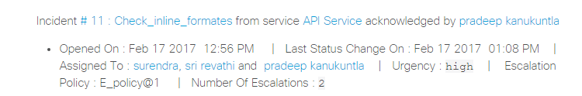

6) Incident resolve

